Linux Commands Execution
pwd – Present working Directory
cd - change directory
echo $0- It will Help to get the details details of the current shell.
cd .. Previous directory
cd ../.. – Two steps back
Ls – list of files
Ll- long list
Ltr- List according to time
Ls- a
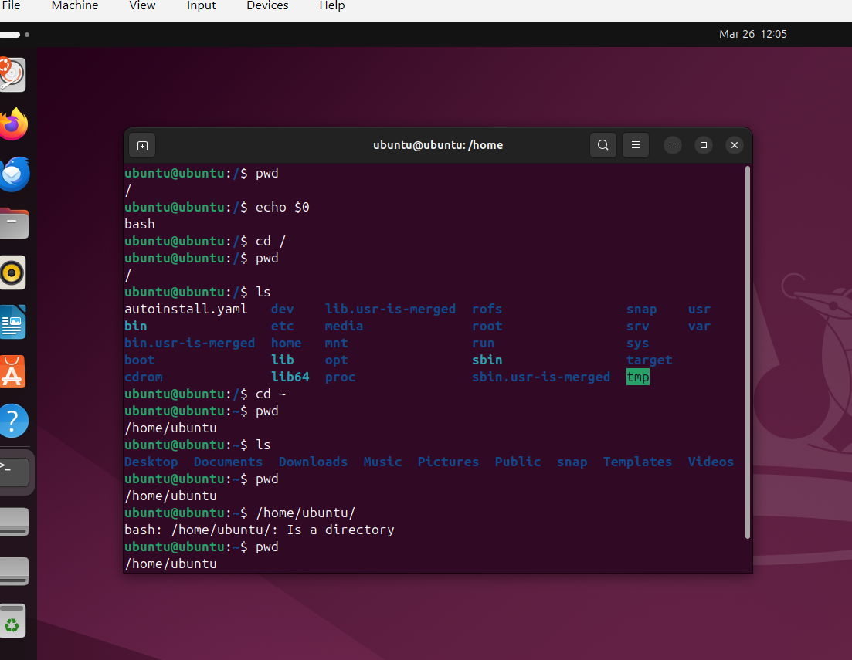

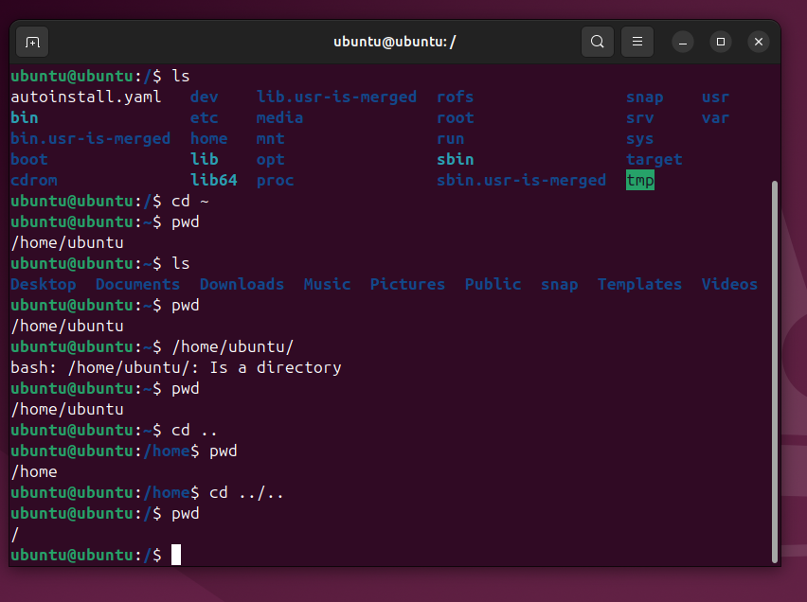
mkdir – To create directory
mv . - To hide the directory
rm -rf – remove/delete the directory
cp – To copy a directory
touch- to create a file inside a folder
vi – To add text to created file
rm file_name - remove/delete a file
rm -rf - remove/delete a directory
cp filename /destination_path - copy a file to destination folder
mv file1 file2 - rename a file from file1 to file2
mv file1 /destination - move file from one location to another
wc file_name - wordcount of file(display number of lines in files)

